Image | Caption (Facebook) | Caption (Instagram)
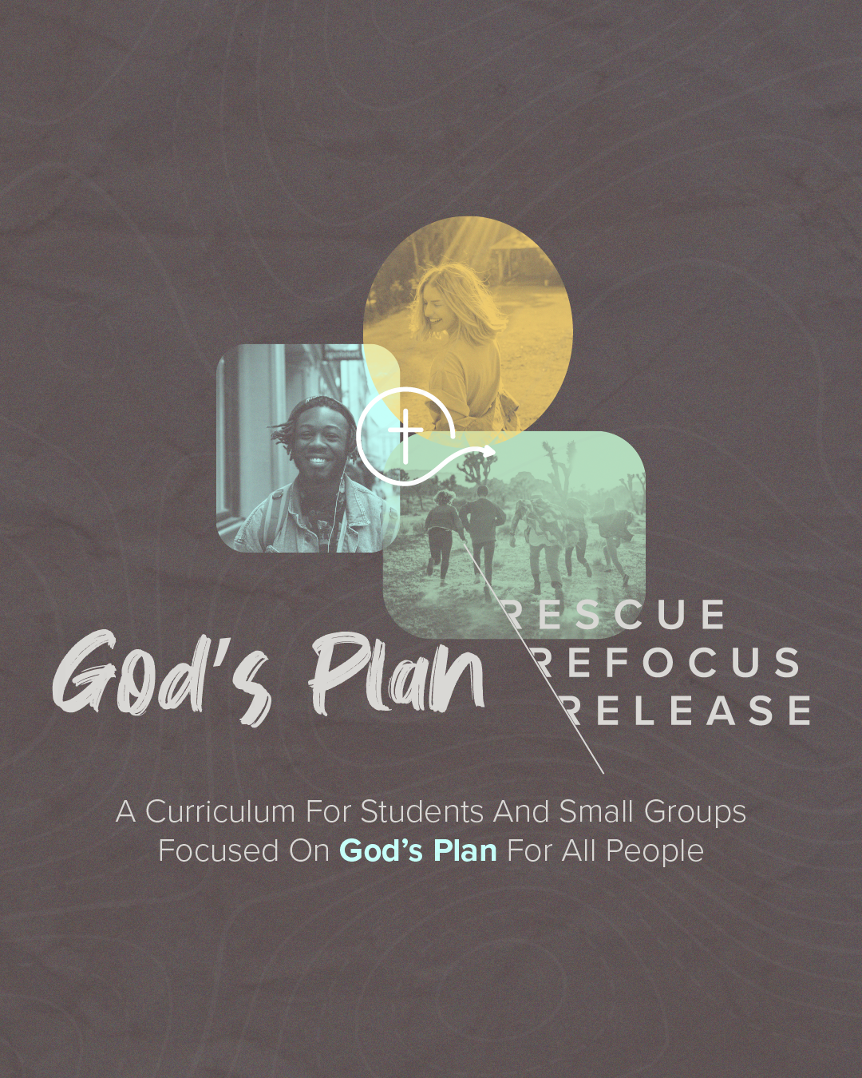 | Have you ever looked around at all the struggles and troubles in the world and thought to yourself, “What is the plan here? Is there even a plan here?” You look up to heaven, shrug your shoulders, and think, “What is going on?”  In the God’s Plan course, we discuss and work through questions like this and many more.  Sign up and join us as we discover God’s Plan for us as believers.  https://www.6degreeinitiative.org/gods-plan-resources | Have you ever looked around at all the struggles and troubles in the world and thought to yourself, “What is the plan here? Is there even a plan here?” You look up to heaven, shrug your shoulders, and think, “What is going on?”  In the God’s Plan course, we discuss and work through questions like this and many more.  Sign up and join us as we discover God’s Plan for us as believers.  Go to the link in our profile // GOD’S PLAN  #6degreeinitiative #convergeww  #westafrica #missions #gospel #unreachedpeoplegroups
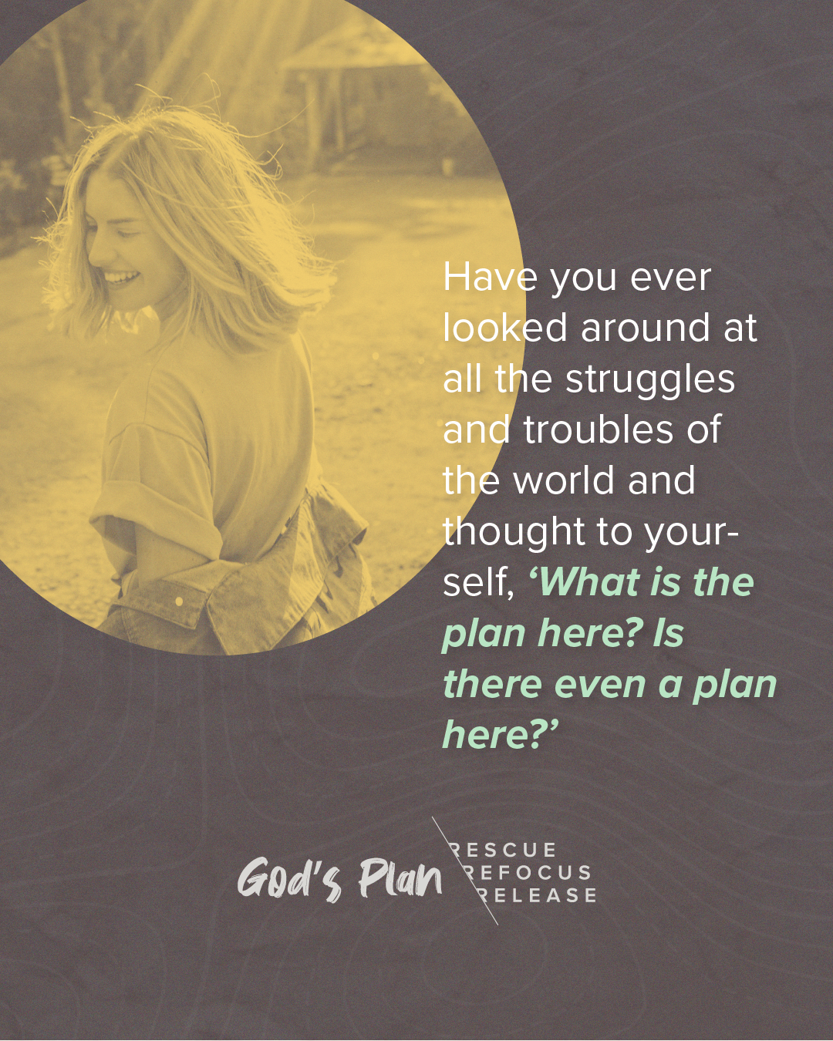 | God’s Plan prepares us for rescue, refocus, and release.  Do you wonder what this looks like in your day-to-day life?  Take 6º Initiative’s God’s Plan course and begin the next steps in your faith journey.  https://www.6degreeinitiative.org/gods-plan-resources | God’s Plan prepares us for rescue, refocus, and release.  Do you wonder what this looks like in your day-to-day life?  Take 6º Initiative’s God’s Plan course and begin the next steps in your faith journey.  See the link in our bio // GOD’S PLAN  #6degreeinitiative #convergeww  #westafrica #missions #gospel #unreachedpeoplegroups
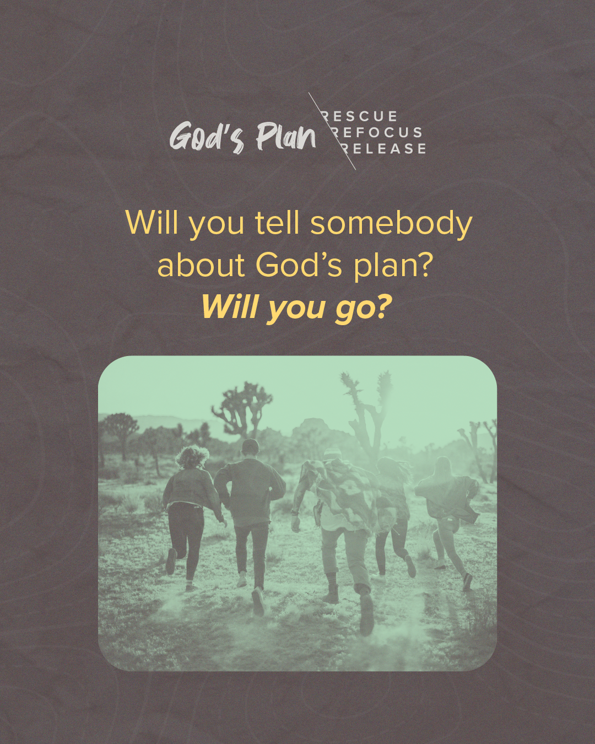 | Are you searching for a curriculum that you and your small group can easily do together?  Do you often wonder what God’s plan is for you as a believer?  6º Initiative God’s Plan course walks you through God’s plan individually and with your small group to go deeper in your relationship with God and grow together as a community.  https://www.6degreeinitiative.org/gods-plan-resources | Are you searching for a curriculum that you and your small group can easily do together?  Do you often wonder what God’s plan is for you as a believer?  6º Initiative God’s Plan course walks you through God’s plan individually and with your small group to go deeper in your relationship with God and grow together as a community.  See the link in our bio // GOD’S PLAN  #6degreeinitiative #convergeww  #westafrica #missions #gospel #unreachedpeoplegroups
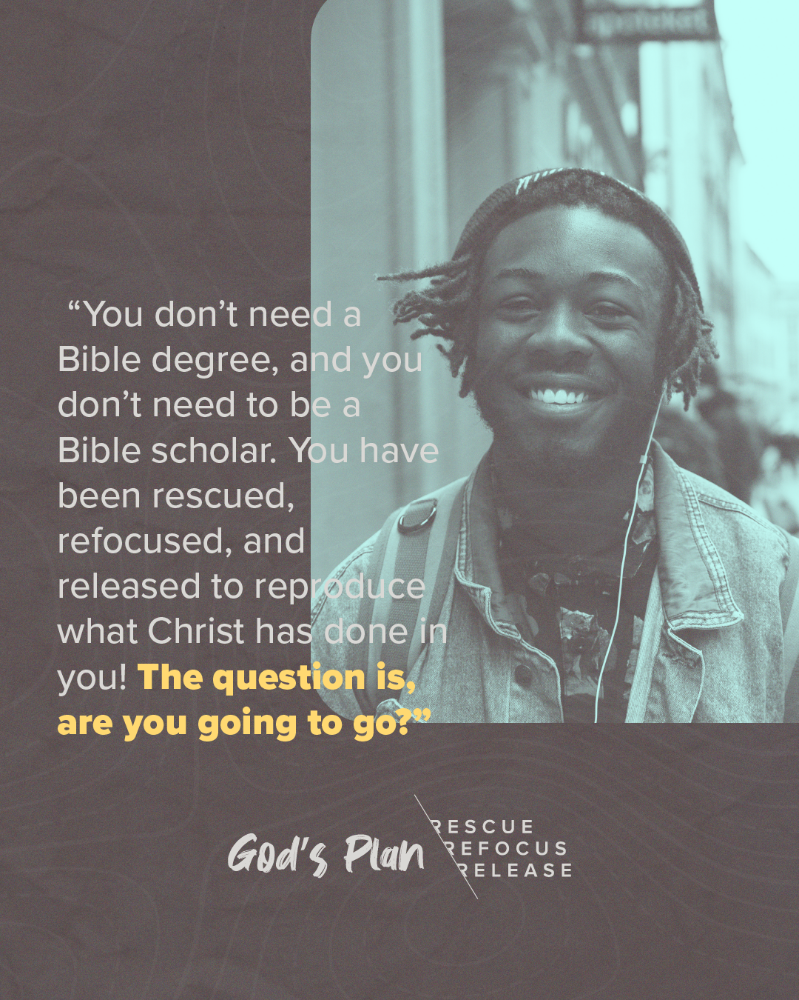 | When you have a plan, you have a clear vision and goal in mind.  Did you know that God ALWAYS has a plan? Do you trust His Plan for your life? For your loved ones?  God’s Plan is a three-week course for individuals, small groups, and churches to help discover what God’s Word says about His plans and how to be a part of what He is doing.  https://www.6degreeinitiative.org/gods-plan-resources | When you have a plan, you have a clear vision and goal in mind.  Did you know that God ALWAYS has a plan? Do you trust His Plan for your life? For your loved ones?  God’s Plan is a three-week course for individuals, small groups, and churches to help discover what God’s Word says about His plans and how to be a part of what He is doing.  Go to the link in our bio // GOD’S PLAN  #6degreeinitiative #convergeww  #westafrica #missions #gospel #unreachedpeoplegroups
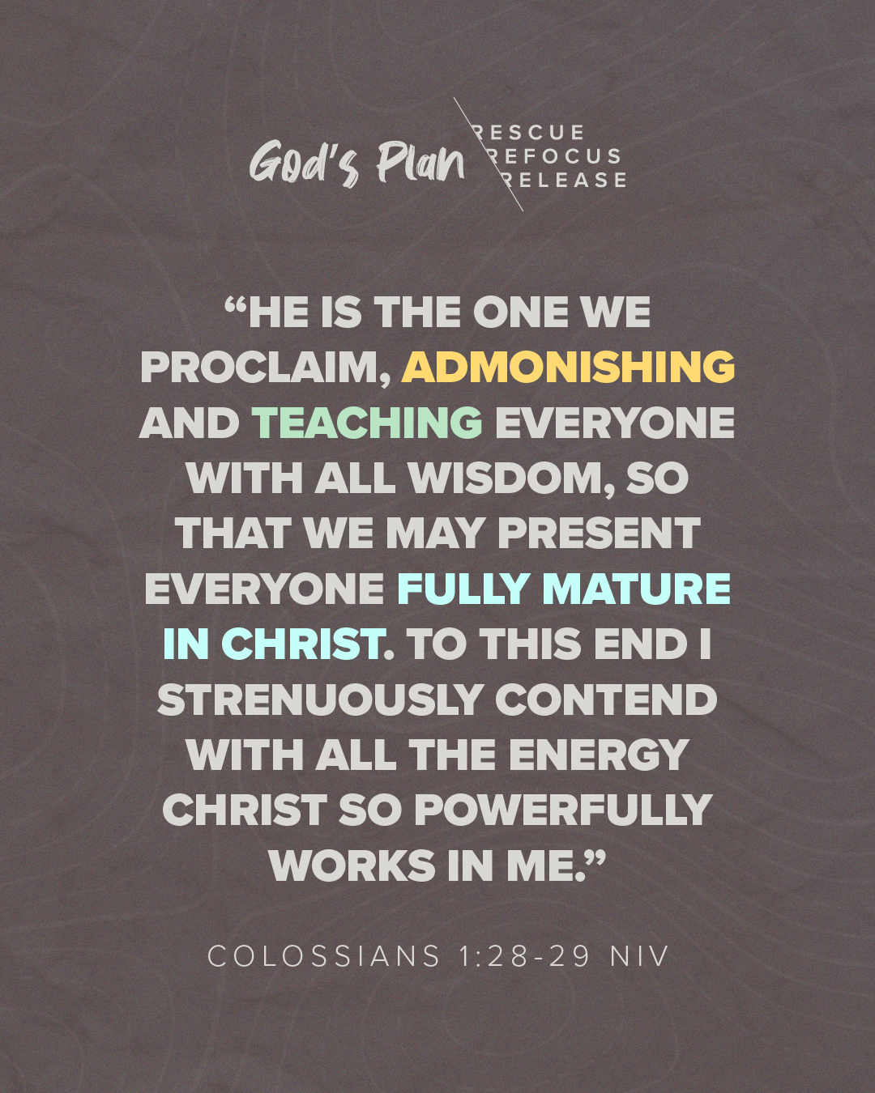 | Did you know 6º Initiative now has a Bible study course you can do individually or as a small group?  The God’s Plan study walks you through specific steps to follow His plan for your life. This removes the complications and confusion and shows clear guidance from the Bible on how to mature in Christ.  Check it out!  https://www.6degreeinitiative.org/gods-plan-resources | Did you know 6º Initiative now has a Bible study course you can do individually or as a small group?  The God’s Plan study walks you through specific steps to follow His plan for your life. This removes the complications and confusion and shows clear guidance from the Bible on how to mature in Christ.  .  Check it out @ the link in our profile // GOD’S PLAN  #6degreeinitiative #convergeww  #westafrica #missions #gospel #unreachedpeoplegroups

